Remote Sensing Imagery: What It Is and What It Can Do for You
By
Randy R. Price
K-State Extension and Research

Introduction:
Remote sensing has been around for the last 30 years and can help farmers evaluate their fields for trouble spots and areas where yield vary. This procedure involves taking a CIR (color infrared) image (Fig. 1) and transforming it into an NDVI image (normalized difference vegetative index). An NDVI image is highly correlated to chlorophyll content, biomass, and the overall healthiness of the plant.

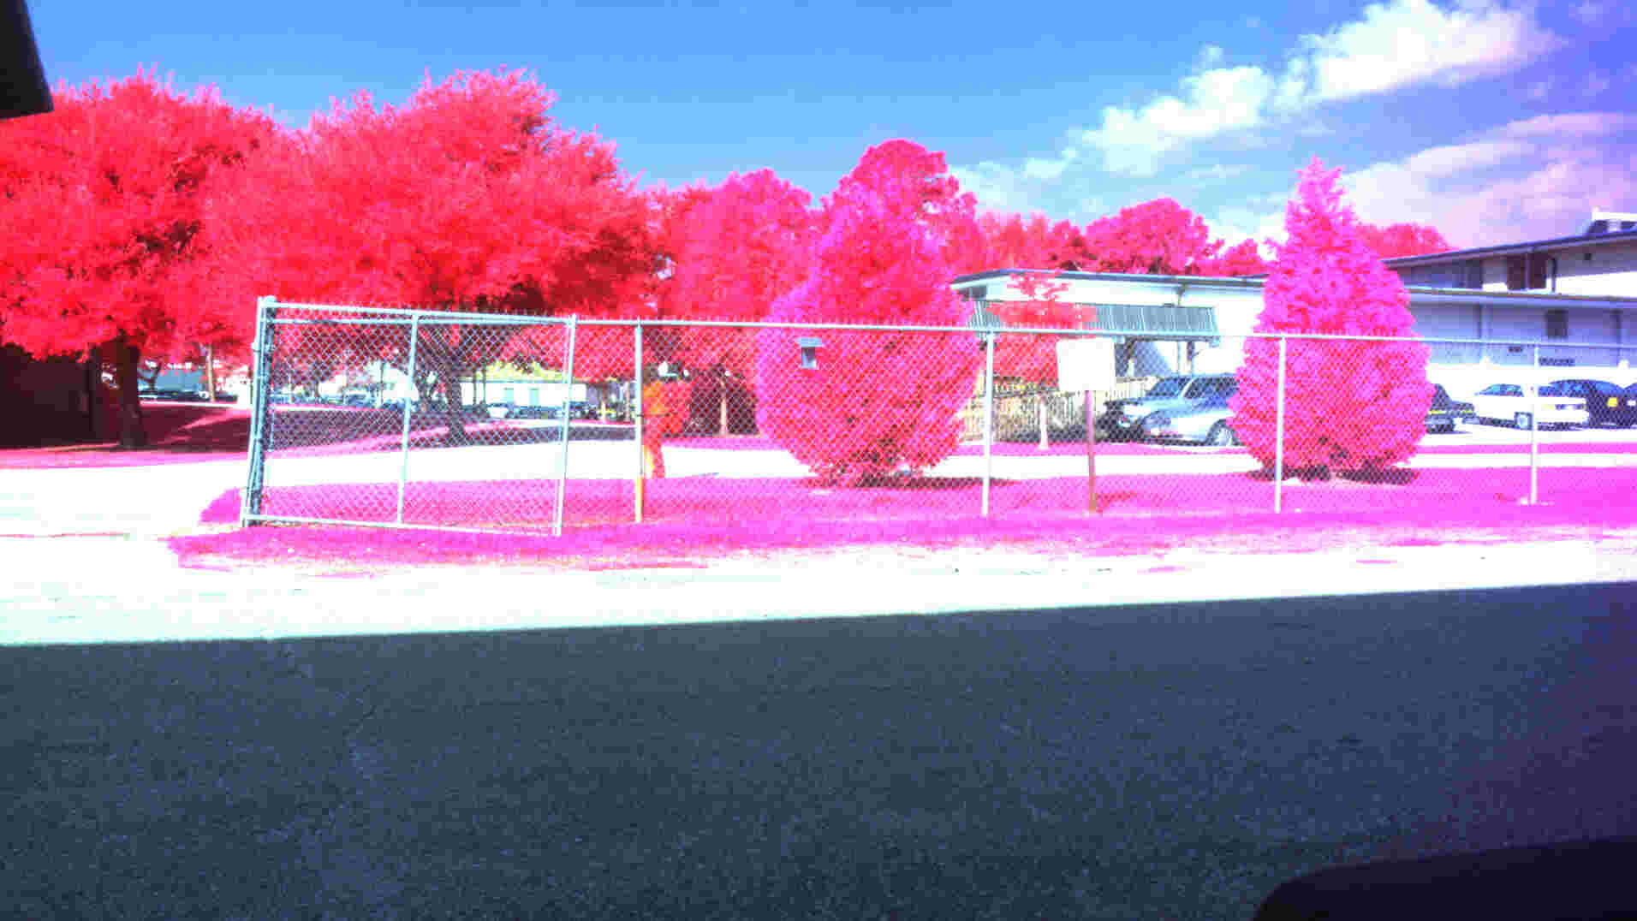
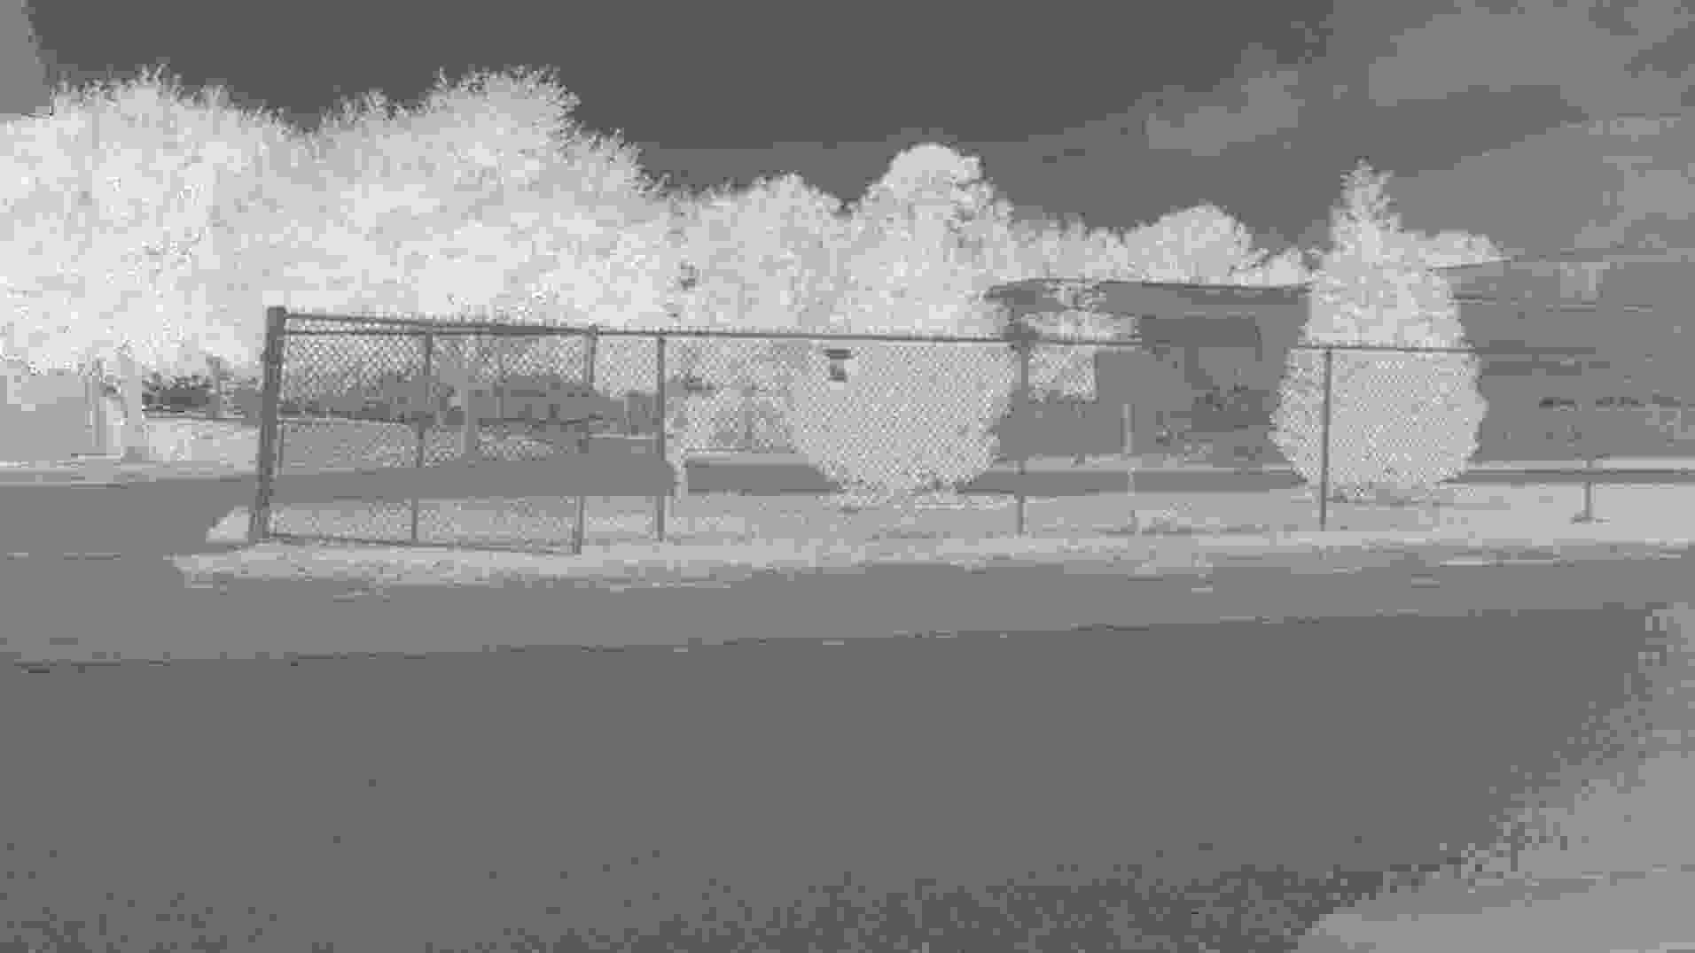
(A)(B)

Figure 1: A CIR image showing different vegetation indices (A) and the corresponding NDVI image (B).

History:
The first remote sensing photos/images were taken from satellites and could see large areas of 10 Km or more. These systems worked well for large area evaluations (such a regions, whole states, or even countries), but not so well for individual fields at farms. Problems were that the resolution was not high enough (being 1 mile or more per pixel) and visit times were too low. A satellite typically only has one chance per week to take an image of field and if a cloud cover is present, you won’t get an image. To make maters worse, many agricultural fields are located in areas where frequent cloud covers exits and can last four to five weeks at a time depending upon weather conditions. These properties caused large problems in image acquisition and greatly limited researchers and farmers who were trying to conduct research on fields.
Newer satellites (ICONOS, SPOT, and Quick Bird®) have eliminated the resolution problem, having better than 1 meter resolution, but still have the visitation problem (since satellites are fairly expensive to put up).
Since that time, remote sensing has largely gone to airplane for agricultural work. Using this approach, a farmer can better schedule imagery when needed and actually get photos in a timely manner. Airplanes imagery can usually provide images with 3 to 10 ft. resolution, and they can fly underneath the cloud cover, or wait until a shadow disappears, to obtain an image.
Still, some newer services are starting to appear where consultants will go out on the internet, and through the various satellite or airplane providers, will find you iamges of farm fields. These services are fairly inexpensive at 1 to 5 dollars per acre.

Cameras Used in the Image Taking Process:
Taking a CIR image requires a special camera that sees in the red and NIR wavelengths (instead of the blue and green as in a regular camera - many times green is included for other indices calculations). The red wavelength exist in the upper portion of what our eyes can see (640 - 680 nm) and the NIR is just above that color (700 to 1100 nm). Note that NIR wavelengths are much different than thermal wavelengths which exist in the 2 um to 10 um range.

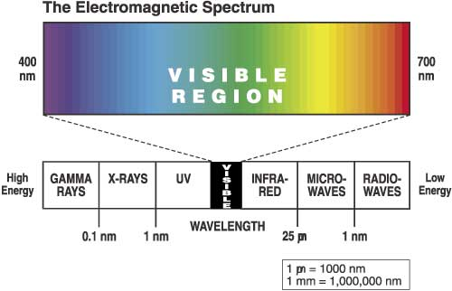

Figure 2: The electromagnetic spectrum showing the visible and infrared portions of the spectrum (source: Wikipedia).

The first cameras to perform the task of red and NIR recordings were doublets or triplets of black and white cameras mounted beside each other and set up to see single wavelengths of red, green, or NIR. These cameras worked well, but had the disadvantage that misalignment of the cameras and thermal flexing of the frame caused differences in pixels alignment of the images (they did not see the same spot on the ground and were shifted). This was a huge problem and caused personnel to have to geo-rectify each image separately. This was fine for large companies, but so good for individual farmers or researchers who wanted to process the data without a large amount of hassle.
During the late 1980’s, a company called Duncantech®, invented a camera that used a special prism and temperature resistant frame to allow 3 separate CCD’s to see the same pixels on the ground (Fig. 3). This camera was a big leap in camera technology having pixel-to-pixel registration between the different images and one image with all the color planes included. Still, these cameras required a frame grabber, full size computer, and were mounted in specially outfitted airplanes. Costs of these systems were in the $8,000 to $13,000 range, and now reside in the $18,000 to $20,000 range. This camera system was sold to Redlake® and then to Geospatial Media who currently markets the camera.
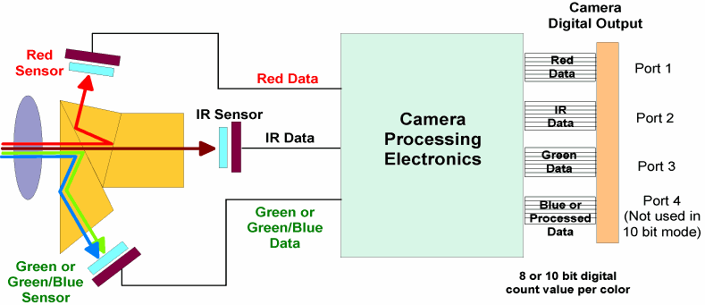
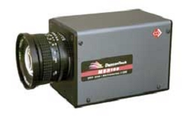
(A) (B)

Figure 3: Duncantech camera: (A) – Basic Camera; (B) – Diagram of internal optics.

Later a company by the name Tetracam®, seeing the need for a low cost agricultural camera, produced a camera called the ADC. This camera was designed for the novice user and had all the features of a hand-held camera - complete image taking and recording in one small unit, small size, light weight, LCD screen). Resolution was 3.2 megapixels which is lower than the Duncantech (which has 4.3 million pixels) but still good enough for agricultural work. Still, these cameras were slightly expensive most farmers (costing $5000) and the processing of images (converting to an NDVI image, geo-rectifying, and getting the data into a site specific software package) was too much work for most people. These cameras are still available today through Tetracam, Inc. A few companies (HP, etc.) have tried to produce and sale a commercial low cost CIR camera, but these cameras did not generate enough sales and were discontinued.
Before an image can be used, it must be geo-rectified. This process is usually done through one of two forms using software such as Arcview GIS® and SMS Agleader Advanced. Most methods include stretching the image to match known GPS coordinates (trees, corners of fields, intersections, etc.) or fitting the field to either a yield map or a field boundary, etc., and selecting the right bands (red and NIR) to automatically perform the NDVI calculation (see paper on “Converting a CIR Image to NDVI Image”).
Because of the high cost of the CIR equipment and the numerous steps involved, most people turn to consultants or special groups to provide this service. Such companies are In-time® and Spectral vision®. These companies for a small fee (usually 3 to 8 dollars per acre) will provide you with a geo-rectified NDVI image. Some are services are complete enough that you view images through the internet, segment into different zones, make prescription or shape files, and then decide to buy once you see the end results. Services depending greatly upon region and state. If you don’t have a service, you will have to make arrangements to get an image, geo-rectify, and process in your own software (be very careful with software as not all software supports NDVI calculations).

What to do with NDVI Images:
Once you have an NDVI image in your site specific software, the next question is what to do with the data? Researches have been spending much time to figure this out and have the following come to the following conclusions:

- A tool for indicating where to crop scout (this reduces man hours in the field).
- Producing applications maps for nitrates and other attributes. This has been especially helpful in irrigated corn and wheat.

NDVI is a good indicator of the relative healthiness of the plant. By noting the color of the chlorophyll, it usually tells how well the plant is doing and if the plant is under stress. Still, the plants must be of the same type and maturity (as different plants will have different NDVI signatures), and most NDVI images are only good to show you where the stress might be occurring, not what is causing (or caused) it. This is where ground thruthing and common knowledge about the field and environmental conditions comes in. Unless you really know the field, and other stressing factors in the area for that particular area and year, you are going to have to make a trip to field to determine what caused the stress. Even then, you might not be able to figure it out. Effects on healthiness of the plant can be caused by many factors including soil textural differences, rainfall amounts, runoff problems, land leveling (leaving the B or C horizon exposed), thin plant populations, topography (which causes differences in soil texture, water availability, organic matter, etc.), nitrate availability, micronutrients, insect damage, and diseases. About any feature that affects plant growth can be the problem. This is where you have to apply some common sense knowledge about the crop, location, history of the field, and current environmental conditions for that year. Some problems occur naturally in the field (such as soil textural differences), and some are seasonal (such as heavy or light rains).
Many times, NDVI images end up showing the same trends as yield maps, but has the advantage that the data is available before the crop is harvested (which gives you a chance to change a management practice to change the outcome of the crop). The down side is that very little data is available on when to best take photos for this work and the cause of stress is not always known. Most work has concentrated on nitrate application where a lower than normal rate is put on during planting, and then the NDVI image is used to indicate where extra nitrates are needed (using a side or top dressed application and an extra trip across the field). This procedure seems to work very well in irrigated corn, but less so in non-irrigated corn (since water limitations can greatly reduce the positive affects of nitrates). If you do evaluate your own imagery, the following guidelines can help:

Certain deductions can be made from the image alone:

- A sudden changes in NDVI value (such as a sudden difference in shift of the NDVI value from one row to the next) is probably from inconsistent farming practices such as:
  - Sprayer problems where the fertilizer truck ran out of fertilizer or a nozzle was clogged or putting out too much / little fertilizer.
  - Combine chaff spreader problems where the ground cover caused the soil to not warm up enough in cold years (was too wet) for good germination and plant growth, or the where sufficient moisture occurred (in dry years).
- Round circular spots:
  - Weed or pest problems which are radiating outward from a central point.
  - A water drainage problem where the soil is too wet and a mud hole occurred, or water is standing.
- Row to row streaking (lightning bolt pattern)
  - Plant population problems caused by:
    - Planter problems
    - Not enough soil moisture
    - Soil texture differences
    - Land leveled problems that reduced or eliminating the A horizon and left less fertile ground on top.
  - Drought problems caused by:
    - Improper irrigation
    - Soil texture

Also, NDVI maps will usually vary in the range of values, shifting up or down from year to year, but showing the same trends (high and low spots) in most normal years dependent upon the environmental conditions (rain, temperature, etc.), and sometimes flipping in very drought stresses years dependent upon soil texture.

Other Uses of Remote Sensing Imagery:
Another interesting use of remote sensing imagery would be the application of the Greenseeker® methods. Many good schemes and nitrate application methods have been testing with this device. Usually, this process is done by applying a nitrate varying strip in the field during planting and then later using the device (which reads out NDVI) to determine if extra nitrates would increase the biomass of the plants. This amount of extra fertilizer is then put on early in the spring to bring the fertilizer amounts up to levels that will supposedly give 100% yield. Currently, the nitrate response strip is suggested to be 10 to 20 feet wide down the whole field. This strip should be big enough to be seen from the air (or even satellite) and could be used to create a nitrate applications map.

Where to get CIR and NDVI images:
If you do deiced to get your own camera, the only two cameras currently available are the MS3100/MS4100 (Geospatial Systems Incorporated) or the Tertracam ADC (Tetracam Inc.). Each of these cameras are quite expensive (MS3100/MS4100 - $18,000 to $24,000 and the ADC Tetracam - $5,000) and you will need access to either an airplane or some other flight means and a way to mount the camera, etc. (that usually has to be FAA approved). In the case of the ADC, you can take a picture out the window of the aircraft if possible.
The best time to take an image is usually at high noon (12:00 to 1:00 P.M. - or when the sun is highest in the sky), since the leaves will tend to follow the sun, plus or minus 2 hours in standard wind conditions (in high wind conditions, the underside of the leaf may show causing lower NDVI values and streaking in the image [winds can roll across fields like waves]). Make sure that the gain (integration times) of each band (red, green, and NIR) are adjusted so that the numbers are not washed out or too dark. This is usually best checked by looking at the recorded image with a histogram function (available in most software packages) and making sure that the histogram levels are not too high (255) or too low (0). The histogram for each band should form a nice Gaussian “bell” shaped curve somewhere in the 0 to 255 range, preferable in the 100 to 180 range (note this value may have to be adjusted from time to time as sunlight changes). Automatic gain control may be used for this (to adjust to a neutral value) and then locking in the value so that multiple photos can be taken and compared.
In partially cloudy conditions, images can be taken, but you must wait until the whole field does not have a cloud spot (a cloud spot will come out much darker in the NDVI calculation and will not be comparable to the other areas of the field). Usually, images from week to week are not comparable in values because of changing sunlight levels, unless a field radiometer is used to record sunlight readings and adjust (normalize) the values. Consult manufactures for these components (although they are not necessary for a single, one time investigation, of a particular). You can also take images during solid cloud cover by flying underneath the cloud cover, although the overall reflectance values will be reduced and you may need to re-adjust the gains to be higher (from full sunlight).

Listing of Services:
If you are interested in obtaining remote sensing services, images, or cameras, here is a list of the places and manufacturers you may want to check:

Services:

InTime Inc:
http://www.gointime.com/
Not currently in Kansas

Cameras:

Tetracam:
21601 Devonshire St. 310
Chatsworth Ca. USA 91311
www.tetracam.com

Geospatial Systems Inc.
125 Tech Park Drive, Rochester, NY 14623
1-585-427-8310 (voice)
1-585-427-8422 (fax)
www.GeospatialSystems.com (web)

Satellite Imagery:

Digital Globe:
Satellite: SPOT / Quick bird – 30 feet or better resolution
1601 Dry Creek Drive
Suite 260
Longmont, CO 80503
USA
Toll-free: 800.655.7929
Phone: 303.684.4000
www.digitalglobe.com
GeoEye
Satellite: IKONOS – 1 meter resolution
21700 Atlantic Boulevard
Dulles, VA 20166
Phone: (703) 480-7500
Fax: (703) 450-9570
www.geoeye.com

Some researchers were loosing more than half their photos during a growing season
Note that processing can still take some time.
SVI, SRI, etc.

